BODY FITNESS PREDICTION
1.INTRODUCTION
1.1Overview:
A gym trainer and monitoring system that has various workout regimes for weight gain and weight loss. Both these options have a trainer. On entering the weight gain trainer it asks for your body weight, height and other answers. Depending on that it calculates your body mass index. It then shows you a workout schedule depending on the amount of weight you need to gain from your current status. It then keeps monthly track of your BMI and completes the cycle when you reach your goal. Similarly the weight loss trainer trains and monitors your workout and provides appropriate training and results.
So,the lifestyle is defined by the absence of physical activity practices throughout the day and causes a decrease in caloric expenditure. This behavior is explained by the inappropriate lifestyle, for example, too much time sitting or lying down and still eating unhealthy foods during this time of immobilization. Currently, a third of the adult world population is physically inactive and this generates 5 million deaths per year (The LAncet, 2012). In addition to contributing to several chronic diseases, physical inactivity also influences mood, sleep quality and body weight.
1.2 purpose:
The objective of the project is answering a simple question, “does exercise/working-out improve a person’s activeness?”. For the scope of this project a person’s activeness was the measure of their daily step-count (the number of steps they take in a day). We are going to build a Machine Learning model which predicts the activeness or inactiveness of a person based on the Mood and number of steps taken in a day. Mood was measured in either "Happy", "Neutral" or "Sad" which were given numeric values of 300, 200 and 100 respectively. Feeling of activeness was measured in either "Active" or "Inactive" which were given numeric values of 500 and 0 respectively.
2.LIRERATIVE SURVEY
2.1 Existing problem:
The previous model have less accuracy and the predictions are not accuarate whereas this model is constrained with the lot of advantages and with a higher accuracy than any other model already proposed. In this model we used Machine learning algorithm named Decision Tree Regression which give an accuracy 30% of the predicted problem and there is an user friendly user interface to check the price of natural will help various stakeholders for natural gas production

2.2 proposed solution:
Machine Learning ( Decision Tree Regression):
Decision Tree Regression is one of the simplest and most common supervised machine learning algorithms that data scientists use for predictive modeling. We’ll use Decision Tree Regression to build a model that predicts the body of calories. And also we have created an UI using the Flask for the body fitness prediction and this UI will allow the users to predict their calories which they was burned very easily and the User interface is user friendly not at least one complication in using the interface, and it can be used just by entering some necessary details into the UI in real time it'll give the predicted value like the calories on that particular day
3. THEORITICAL ANALYSIS
3.1 Block diagram:
3.2 Hardware / software designing
Hardware:
- Processor – i3 or above one.
- Hard Disk – 500 GB.
- Memory – 4GB RAM.

Software:
● Jupyter Notebook Environment and Google Colab
● Spyder IDE
● Machine Learning Algorithms
With the help of below software we can develop flask apk that is

- Anaconda software.
It give’s some default libraries like
- Numpy:
It is an open-source numerical Python library. It contains a multidimensional array and matrix data structures and can be used to perform mathematical operations
- Scikit-learn:
It is a free machine learning library for Python. It features various algorithms like support vector machine, random forests, and k-neighbours, and it also supports Python numerical and scientific libraries like NumPy and SciPy

- Scikit-image
Scikit-image, or skimage, is an open source Python package designed for image preprocessing.
- Matplotlib and Seaborn:
Matplotlib is mainly deployed for basic plotting. Visualization using Matplotlib generally consists of bars, pies, lines, scatter plots and so on. Seaborn: Seaborn, on the other hand, provides a variety of visualization patterns. It uses fewer syntax and has easily interesting default themes.
- Flask:
Web framework used for building Web applications
- Html
It is for the webview which be build
4. EXPERIMENTAL INVESTIGATION
The dataset we used is derived from https://github.com/datasets/natural-gas It contains plenty of datasets which are real time. We choose body fitness prediction dataset which contains 7 attributes and 97 rows After that, the missing values are checked and the unwanted columns are deleted, and we have retained to attributes. Those are shown below.
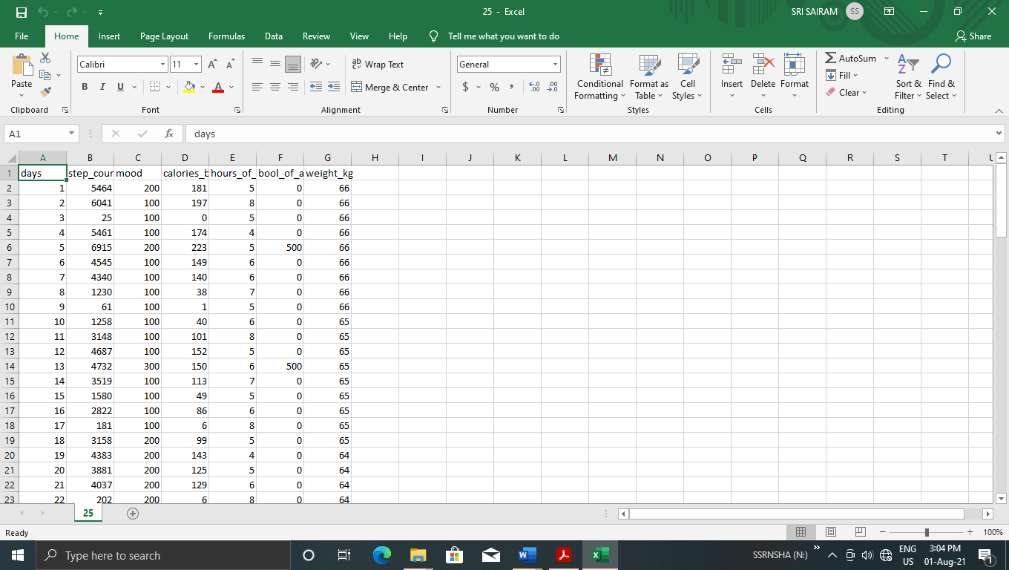

5.FLOW CHAT:

6.RESULT:
Here we used logistic regression to work out on a predicting and analysing urban water quality using machine learning to tell whether the water is sustainable or not.
This can be checked by giving the details of the contents of water and predict the water quality.
The output is as follows:
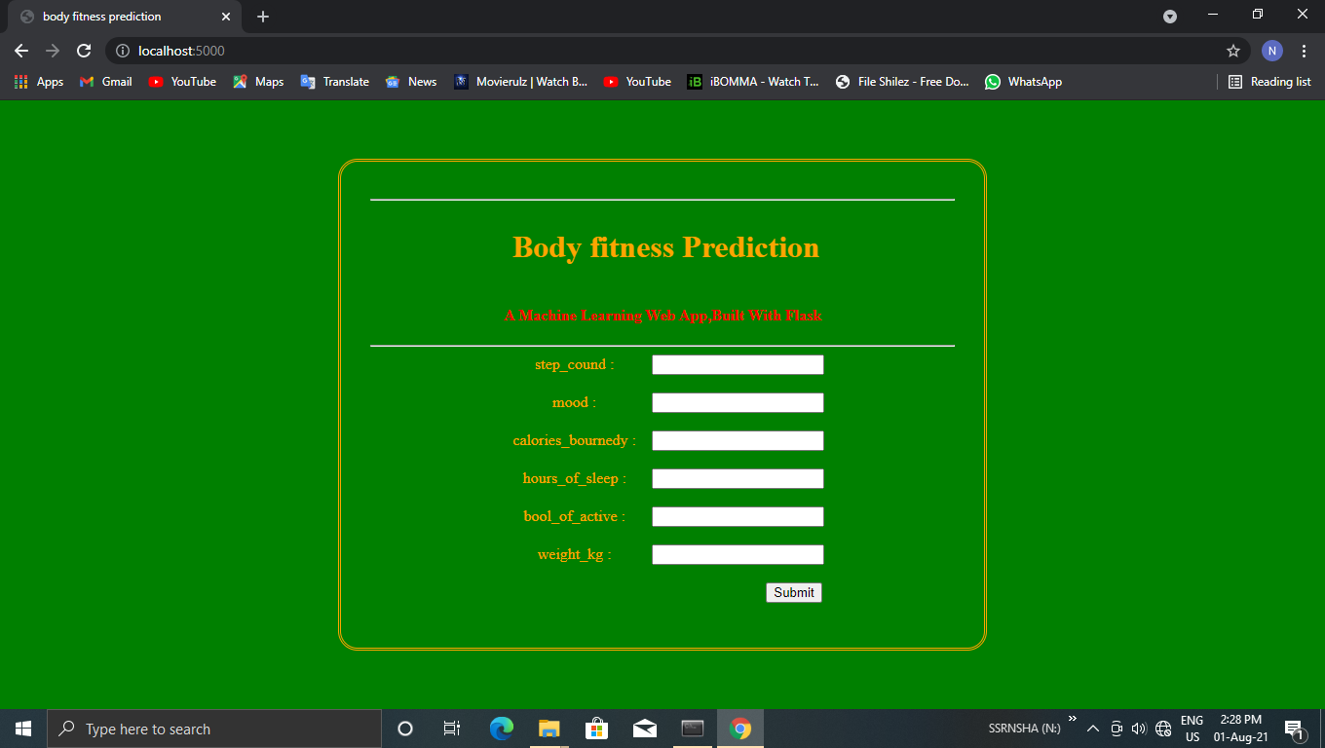
After giving the suitable inputs we get the output as shown below:
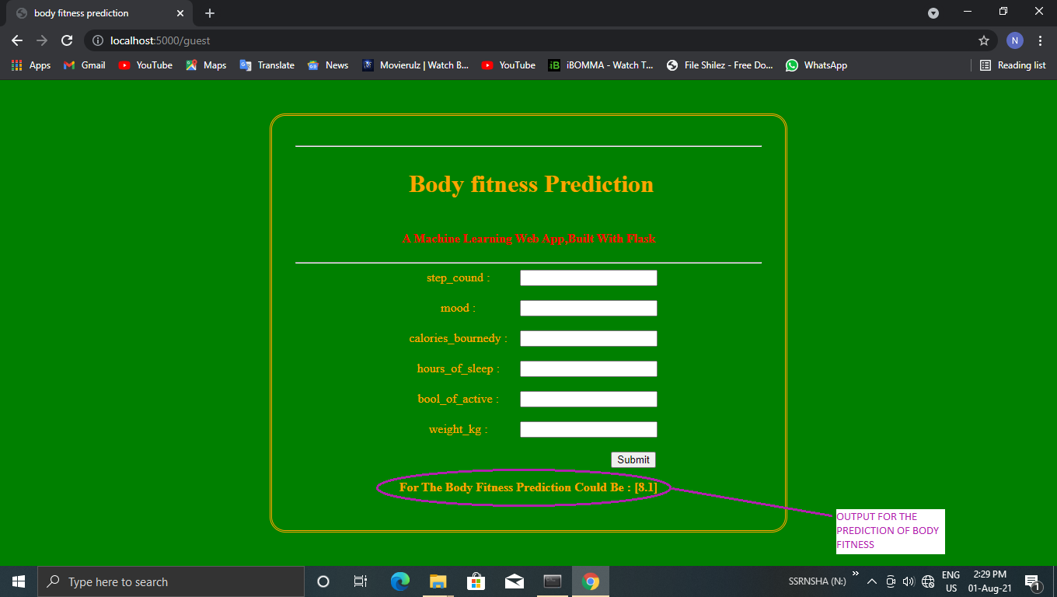

7.ADVANTAGES AND DISADVANTAGES
Advantages:
- reduce your risk of a heart attack.
- manage your weight better.
- have a lower blood cholesterol level.
- lower the risk of type 2 diabetes and some cancers.
- have lower blood pressure.
- have stronger bones, muscles and joints and lower risk of developing osteoporosis.
- lower your risk of falls.

Disadvantages:
- Exercise is addictive. ...
- Exercise Hurts The Heart. ...
- Exercise is associated with body perception disorders. ...
- Exercise can break up families. ...
- Exercise can cause diabetes. ...
- Exercise causes inflammation. ...
- Exercise is stressful. ...
- Exercise causes premature aging.

8.APPLICATIONS
- we can also use this model to predict , different sectors like business, bank, salaries etc...
- This system can be used in single gyms.
- This system can be used to manage a chain of gyms.

9.CONCLUSION
Machine learning techniques have been shown to provide solid prediction capabilities in various application domains including medicine and healthcare. In this study, we presented an evaluation and comparison of six popular machine learning techniques on predicting the patients who could be at risk of developing hypertension using medical records of Cardiorespiratory Fitness from the Henry Ford Testing (FIT) Project. The results show that it is not necessarily that the more complex the machine learning model, the better prediction accuracy that can be achieved. Simpler models can perform better in some cases as well. The results have also shown that it is critical to carefully explore and evaluate the performance of the machine learning models using various model evaluation methods as the prediction accuracy can significantly differ. These results confirm the explorative nature of the machine learning process that requires iterative and explorative experiments in order to discover the model design that can achieve the target accuracy for a specific problem.
10. FUTURE SCOPE
This Decision Tree Regression model can also be used in the future predictions like weather forecast, job prediction, salary prediction etc. In further study, we will try to conduct experiments on larger data sets or try to tune the model so as to achieve the state -of-art performance of the model and a great UI support system making it complete web application

11. BIBILOGRAPHY
- 1.Jeppesen J, Hein HO, Suadicani P, Gyntelberg F. High triglycerides and low HDL cholesterol and blood pressure and risk of ischemic heart disease. Hypertension. 2000;36(2):226–232. pmid:10948082
  - View Article
  - PubMed/NCBI
  - Google Scholar
- 2.Whelton PK, Carey RM, Aronow WS, Casey DE, Collins KJ, Dennison Himmelfarb C, et al. 2017 ACC/AHA/AAPA/ABC/ACPM/AGS/APhA/ASH/ASPC/NMA/PCNA Guideline for the Prevention, Detection, Evaluation, and Management of High Blood Pressure in Adults. Journal of the American College of Cardiology. 2017.
  - View Article
  - Google Scholar
- 3.Organization WH, et al. Clinical guidelines for the management of hypertension; 2005.
- 4.Chowdhury R, Kunutsor S, Vitezova A, Oliver-Williams C, Chowdhury S, Kiefte-de Jong JC, et al. Vitamin D and risk of cause specific death: systematic review and meta-analysis of observational cohort and randomised intervention studies. Bmj. 2014;348:g1903. pmid:24690623
  - View Article
  - PubMed/NCBI
  - Google Scholar
- 5.Carson JL, Sieber F, Cook DR, Hoover DR, Noveck H, Chaitman BR, et al. Liberal versus restrictive blood transfusion strategy: 3-year survival and cause of death results from the FOCUS randomised controlled trial. The Lancet. 2015;385(9974):1183–1189.
  - View Article
  - Google Scholar
- 6.Kung HC, Xu J. Hypertension-related Mortality in the United States, 2000-2013. NCHS data brief. 2015;(193):1–8. pmid:25932893
  - View Article
  - PubMed/NCBI
  - Google Scholar
- 7.Al-Mallah MH, Keteyian SJ, Brawner CA, Whelton S, Blaha MJ. Rationale and design of the Henry Ford Exercise Testing Project (the FIT project). Clinical cardiology. 2014;37(8):456–461. pmid:25138770
  - View Article
  - PubMed/NCBI
  - Google Scholar
- 8.Bruce R, Kusumi F, Hosmer D. Maximal oxygen intake and nomographic assessment of functional aerobic impairment in cardiovascular disease. American heart journal. 1973;85(4):546–562. pmid:4632004
  - View Article
  - PubMed/NCBI
  - Google Scholar
- 9.Members C, Gibbons RJ, Balady GJ, Bricker JT, Chaitman BR, Fletcher GF, et al. Journal of the American College of Cardiology. 2002;40(8):1531–1540.
  - View Article
  - Google Scholar
- 10.Juraschek SP, Blaha MJ, Whelton SP, Blumenthal R, Jones SR, Keteyian SJ, et al. Physical fitness and hypertension in a population at risk for cardiovascular disease: the Henry Ford ExercIse Testing (FIT) Project. Journal of the American Heart Association. 2014;3(6):e001268. pmid:25520327
  - View Article
  - PubMed/NCBI
  - Google Scholar
APPENDIX
SOURCE CODE:
Html & css :
<html>
<head>
<title>body fitness prediction</title>
<style>
body
{
background-color:green;
}
label
{
width:150px;
display:inline-block;
}
#form{
border-radius:20px;
border-style:double;
color:orange;
width:600px;
padding:30px;
}
h2{
text-align:center;
}
.center{
text-align:center;
}
{
width: 150px;
text-align: center;
margin:0 auto;
}
.container {
margin-left:45%;
}
html, body { height: 100%; } html { display: table; margin: auto; } body { display: table-cell;
vertical-align: middle;
}
.design{
color:red;
}
</style>
<body>
<div id="form" class="center"><hr>
<marquee><h1> Body fitness Prediction</h1></marquee>
<h4 class="design">A Machine Learning Web App,Built With Flask</h4><hr>
<form class="center" action = "/guest" method = "post">
<label for="step_cound">step_cound : </label>
<input type="text" id="step_cound" name="sc"><br> <br>
<label for="mood">mood : </label>
<input type="text" id="username" name="m"><br><br>
<label for="calories_bourned">calories_bournedy : </label>
<input type="text" id="username" name="cb"><br><br>
<label for="hours_of_sleep">hours_of_sleep :</label>
<input type="text" id="username" name="hos"><br><br>
<label for="bool_of_active">bool_of_active :</label>
<input type="text" id="username" name="boa"><br>
<br>
<label for="weight_kg">weight_kg : </label>
<input type="text" id="username" name="wk"><br>
<br>
<div class="container">
<button> Submit </button>
</div>
</form>
<p><b>{{y}}</b></p>
</body>
</htmml>

App.py:
from flask import Flask, render_template , request
import pickle

model = pickle.load(open("body.pkl",'rb'))

app = Flask(__name__)
@app.route('/')
def hello_world():
return render_template("index.html")
@app.route('/guest', methods = ["POST"])
def guest():
sc = request.form["sc"]
m = request.form["m"]
cb = request.form["cb"]
hos = request.form["hos"]
boa = request.form["boa"]
wk = request.form["wk"]
data = [[int(sc),int(m),int(cb),int(hos),int(boa),int(wk)]]
prediction = model.predict(data)

return render_template("index.html",y = "For The Body Fitness Prediction Could Be : " + str(prediction))
app.run(debug = True)

